Sentence Type #2
Compound Sentence
English 10 – Estabrook

Name: ______________________________

A definition:
A compound Sentence is created when two (or more) simple sentences (independent clauses) are JOINED together with a , (comma) and a coordinating conjunction.
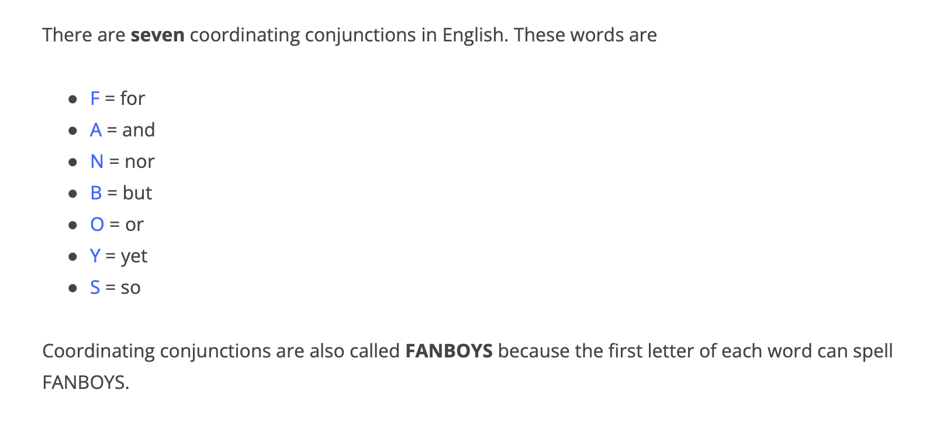
Coordinating conjunctions can, and do, JOIN words, phrases, clauses. We are learning about coordinating conjunctions joining clauses! More specifically independent clauses which are also known as simple sentences!
Remember a simple sentence begins with a capital letter, has a subject and a predicate and end punctuation.

Example: I am hungry. I do not have any food. Two simple sentences

With a coordinating conjunction pattern looks like this:
{Simple sentence} , [FANBOYS] {simple sentence} .!?

FOR – used to show cause & effect (similar to ‘because’)
She was tired, for she did not sleep well last night.

AND – used to join two related ideas (the ideas do not contrast)
I went to the store, and I bought a banana.

NOR – used with two negative ideas (note: nor is often used with neither)
I did not like the movie nor did my sister.

But – used to show contrast between two ideas (one idea is often positive, but the other is negative)
I went to the store, but it was closed.

Or – used to join two different choices
You can take the bus, or you can walk with me.

Yet: used for contrast (the same as but)
The movie was boring, yet I watched all of it.

So – used for cause & effect (similar to for but the order of ideas is the opposite)
She did not sleep last night, so she was tired.

Try these:

- It was raining, we still had fun.

- I could not go into the store, it was closed.

- She was quite sleepy, she continued to study.

- Tina didn’t want to exercise, did she want to study.

- The children saw lions, they saw a baby tiger at the zoo.

- Tomorrow it might be cloudy, it might be sunny.

- It was cold outside, we stayed inside.

- They visited the museum, the amusement park was their favouite.

